
Application Penetration Test
<Engagement Name>

This report has been produced by <Vendor> for

DSG Adversarial Testing
KPMG US

PPA - <PPA>
PTI - <PTI>
RP - <RP>

<Type of Test, Initial/Retest/etc.>
<MONTH DD, YYYY>

This report is to assist with vulnerability remediation activities. This report does not carry an endorsement from the KPMG US Adversarial Testing Team.

This report is KPMG CONFIDENTIAL and for KPMG INTERNAL USE ONLY and its content cannot be shared or distributed in any form with a third-party client or vendor without initiating the client inquiry process.

Contents
Executive Summary 1
Background and Scope 1
Summary of Findings 1
Assessment Details 2
Detailed Findings 3
Appendix 8
Risk Rating Criteria 9
Terminology 10
Methodology 11
DSG Disclaimer Notice 12

Assessment Overview
Timeline
Assessment Start Date | <MM/DD/YYYY>
Assessment Completion Date | <MM/DD/YYYY>
Report Completion | <MM/DD/YYYY>
Team
Name | Role | Email
<First Last> | <Role, e.g. Tester @ Vendor> | <email>
<First Last> | <Role, e.g. Tester @ Vendor> | <email>
<First Last> | <Role, e.g. Tester @ Vendor> | <email>
<First Last> | <Role, e.g. Tester @ Vendor> | <email>
Report History
Name | Company | Date | Description
<First Last> | <Vendor> | <MM/DD/YYYY> | <Initial Draft>
<First Last> | <Vendor> | <MM/DD/YYYY> | <Revisions>
<First Last> | <Vendor> | <MM/DD/YYYY> | <Revisions>
<First Last> | <Vendor> | <MM/DD/YYYY> | <Peer Review>
<First Last> | <Vendor> | <MM/DD/YYYY> | <Final Review>

Executive Summary

Background and Scope
As part of the Digital Security Group’s (DSG) Adversarial Testing Program, <vendor> conducted a <dynamic automated or manual> vulnerability assessment and penetration test of the <application name> application.
The <vendor> team performed time-boxed security testing using a hybrid model of manual testing and automated scanning. For its automated analysis, <vendor> leveraged industry-standard tools, including HCL AppScan and other open-source testing software. The purpose of this engagement was to identify potential vulnerabilities within the application. The manual assessment complemented the automated scans, covering key areas such as information gathering, configuration management, authentication, authorization, session management, and input validation to identify security issues that could affect the application.
The <vendor> team identified a total of <number> findings (from both automated and manual testing), which were categorized across various severity levels. During the automated scan, the tools analyzed <number> links and generated <number> initial findings. Of these, <number> were validated and reported, <number> were deemed Informational, and the rest were confirmed as false positives.

Summary of Findings
During this assessment, <word number> (<#>) findings across all phases of testing were identified. Each finding has been classified into categories of Very High, High, Medium, Low, and Informational (<#> Very High, <#> High, <#> Medium, <#> Low, <#> Informational) based on the risk level.
The table below details the findings discovered during the assessment. Each finding has been assigned a risk rating based on its potential impact to the firm and the likelihood of exploitation. These ratings provide a baseline for prioritization but should be evaluated within the broader context of the organization's security posture and existing compensating controls. The results of this assessment represent a point-in-time analysis of the application's security.

# | Finding | Dependency | Prior Test | Likelihood | Impact | Risk Rating
1 | Concurrent User Session | Application |  |  |  | Informational
2 | Server Technology disclosure in Server Response Headers | Application |  |  |  | Informational
3 | CBC-mode Encryption Cipher Suites Supported in TLS | Application |  |  |  | Informational

Assessment Details
In addition to the findings summarized above, several assessment parameters provide context for the scope and configuration of the test. These details outline the environment, roles, and conditions under which the application was evaluated and should be considered when reviewing the overall results. The table below captures the key inputs and constraints of the assessment.

Field | Details
Test URL | https://shielddev.servicenowservices.com/navpage.do
Testing Environment | NA
Number of Access Level in Scope | NA
User Roles | user1testad1@dev.uskgc.com  testaduser2@dev.uskgc.com  user3testad3@dev.uskgc.com
Scope of Test | SSO
Testing Window | 03/02/2026 to 03/04/2026
Point of Contact (App Team) | Collier, Mick

Limitations
<N/A, Details, etc.>

Additional Notes
<N/A, Details, etc.>

Detailed Findings
Finding 1: Concurrent User Session
Informational
Dependency: Application
Status: Open
Description: During the Single Sign-On (SSO) configuration review and testing of the application authentication flow, it was observed that the application allows multiple concurrent sessions for the same user account from different browsers and client IP addresses. During testing, the same user account was able to authenticate successfully from multiple browser sessions simultaneously without invalidating the previously established session. Both sessions remained active and were able to access the application at the same time.
Allowing concurrent sessions is typically a design decision depending on the organization’s security policy. However, in certain environments where sensitive data is handled, limiting concurrent sessions or notifying users of simultaneous logins can help reduce risks associated with session misuse, credentials sharing, or unauthorized access.
If organizations require stricter session management controls, mechanisms should be implemented to detect and manage concurrent sessions appropriately.
Affected Systems & Locations:
https://shielddev.servicenowservices.com/navpage.do
Reproduction Steps:
Open the application login page and authenticate using valid user credentials through the configured SSO provider (Azure).
Once authentication is successful, access the application dashboard and verify that the user session is active.
Open a new browser session and login in again using the same user account through the SSO authentication flow.
After the second authentication is completed, verify that both browser sessions remain active.
Confirm that both sessions can access the application simultaneously without any session termination or warning.
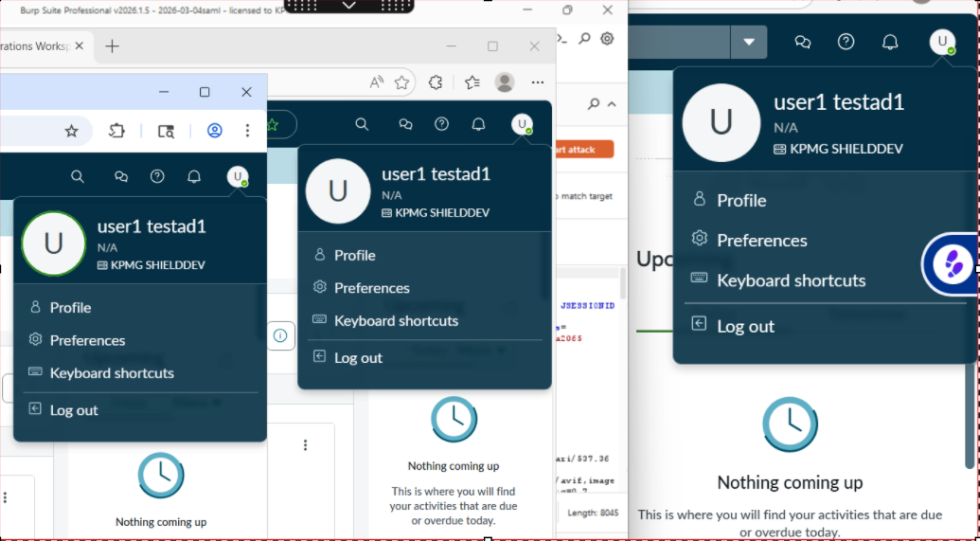
Figure 1
Remediation:
It is recommended that web applications implement enhanced session management capabilities where appropriate. These may include:
- Providing users with visibility into their active sessions and login activity.
- Implementing controls to limit the number of concurrent sessions allowed per user account.
- Notifying users when multiple sessions are active simultaneously.
- Providing functionality to remotely terminate active sessions.
- Logging session activity such as login time, client IP address, device information, and session duration for monitoring purposes.
Also consider implementing configurable session management policies based on their risk tolerance and security requirements.
Closing/Downgrading Justification:

Finding 2: Server Technology Disclosure in HTTP Response Headers
Informational
Dependency: Application
Status: Open
Description: During testing, it was observed that the application discloses backend server information in the HTTP response headers. Specifically, the response to the /sp/metadata endpoint includes the follow header:
Server: snow_adc
This header reveals information about the server infrastructure handling the request. Exposing server technology details can assist attackers in performing reconnaissance and identifying the underlying platform used by the application.
Such information can allow attackers to:
Fingerprint the application infrastructure.
Identify platform-specific vulnerabilities.
Tailor attacks against known weakness of the disclosed technology.
Although this issue does not directly expose sensitive data or allow immediate exploitation, minimizing unnecessary information disclosure is considered a security best practice.
Affected Systems & Locations:
https://shielddev.servicenowservices.com/navpage.do
Reproduction Steps:
- Send an HTTP request to the following endpoint:
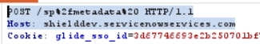
Figure 1
2. Inspect the HTTP response headers.
3. Observe that the response includes the following header revealing the server technology:
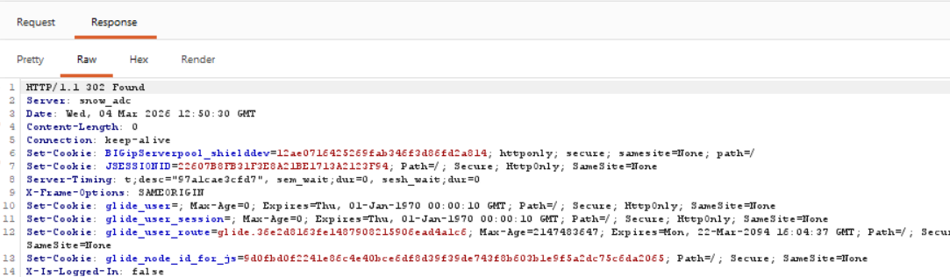
Figure 2
4. The response returns HTTP status 200 ok along with the server identification header.
Remediation:
It is recommended to suppress or modify server identification headers to prevent unnecessary disclosure of backend infrastructure information.
- Removing or masking the Server header in HTTP responses.
- Configuring the web server or reverse proxy to return generic server information.
- Implementing header filtering at the load balancer or application level.

Reducing exposed infrastructure details helps limits reconnaissance opportunities for attackers.
Closing/Downgrading Justification:

Finding 3: CBC-mode Encryption Cipher Suites Supported in TLS
Informational
Dependency: Application
Status: Open
Description: During the TLS configuration assessment of the application endpoint, it was observed that the server supports cipher suites utilizing Cipher Block Chaining (CBC) mode encryption.
CBC-mode cipher suites have historically been associated with cryptographic weakness such as the Lucky 13 timing attack, which theoretically allows attackers to recover plain text from encrypted TLS communications under specific circumstances.
Although modern TLS implementation typically includes mitigations against such attacks, the continued support of CBC-mode cipher suites increases the potential attack surface and allows the use of legacy encryption mechanisms.
Additionally, several cipher suites utilizing RSA key exchange are supported. These cipher suites do not provide Forward Secrecy, meaning that if the server’s private key is compromised in the future, previously recorded encrypted sessions could potentially be decrypted.
While the server also supports modern and secure cipher suites using AES-GCM, the presence of CBC-based and RSA key exchange cipher suites indicates that the TLS configuration allows legacy cryptographic options.
Industry security guidelines recommend disabling legacy cipher suites and prioritizing modern authenticated encryption algorithms.
Affected Systems & Locations:
https://shielddev.servicenowservices.com/navpage.do
Reproduction Steps:
Navigate to SSL labs TLS testing tool or equivalent TLS scanner. Scan the endpoint
Review the TLS configuration section of the scan results.
Observe that the server supports CBC-mode cipher suites including:
TLS_ECDHE_RSA_WITH_AES_128_GCM_SHA256 (0xc02f) ECDH x25519 (eq. 3072 bits RSA) FS | 128
TLS_ECDHE_RSA_WITH_AES_256_GCM_SHA384 (0xc030) ECDH x25519 (eq. 3072 bits RSA) FS | 256
TLS_ECDHE_RSA_WITH_AES_128_CBC_SHA256 (0xc027) ECDH x25519 (eq. 3072 bits RSA) FS WEAK | 128
TLS_ECDHE_RSA_WITH_AES_128_CBC_SHA (0xc013) ECDH x25519 (eq. 3072 bits RSA) FS WEAK | 128
TLS_ECDHE_RSA_WITH_AES_256_CBC_SHA384 (0xc028) ECDH x25519 (eq. 3072 bits RSA) FS WEAK | 256
TLS_ECDHE_RSA_WITH_AES_256_CBC_SHA (0xc014) ECDH x25519 (eq. 3072 bits RSA) FS WEAK | 256
TLS_RSA_WITH_AES_128_GCM_SHA256 (0x9c) WEAK | 128
TLS_RSA_WITH_AES_256_GCM_SHA384 (0x9d) WEAK | 256
TLS_RSA_WITH_AES_128_CBC_SHA256 (0x3c) WEAK | 128
TLS_RSA_WITH_AES_256_CBC_SHA256 (0x3d) WEAK | 256
TLS_RSA_WITH_AES_128_CBC_SHA (0x2f) WEAK | 128
TLS_RSA_WITH_AES_256_CBC_SHA (0x35) WEAK
The scan also identifies several cipher suites marked as Weak, indicating legacy cryptographic support.

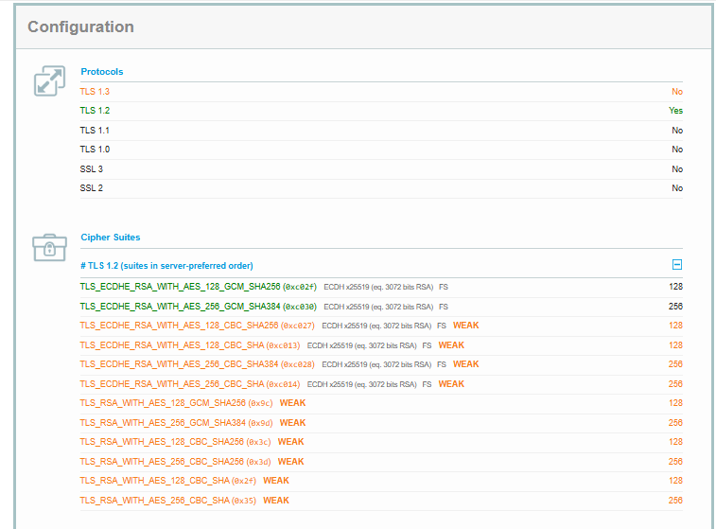
Figure 1
Remediation:
It is recommended to update the TLS configuration to disable legacy CBC-mode and RSA key exchange cipher suites and prioritize modern authenticated encryption cipher suites.
Disable cipher suits utilizing CBC mode encryption where compatibility allows.
Disable RSA key exchange cipher suites to ensure Forward Secrecy.
Enable TLS 1.3 were supported by the application infrastructure.
These changes will strengthen the overall TLS security posture of the application.
Closing/Downgrading Justification:

Finding 4: Session Expiration Handling Displays Modal Instead of Re-directing to Login
Informational
Dependency: Application
Status: <Open, Closed, etc.>
Description:
During testing it was observed that when the user session expires in the Service Operation Workspace interface, the application displays a session expiration popup instead of immediately redirecting the user to the login page.
The message displayed is
Session expired (401)
Required to provide Auth information.
After closing the popup using the close button, the application reloads the same page instead of redirecting the user to the authentication page. This behavior appears to be related to the SPA architecture used by the ServiceNow workspace interface, where authentication is handled through background API requests rather than full page redirects.
No unauthorized access to data was observed after the session expired. The application still requires authentication to access protected resources.
Affected Systems & Locations:
https://shielddev.servicenowservices.com/navpage.do
Reproduction Steps:
- Log in to the application as any valid user.
- Navigate to the Service Operation Workspace.
- Allow the session to expire or manually invalidate the session.
- Observe that the application displays the following popup.
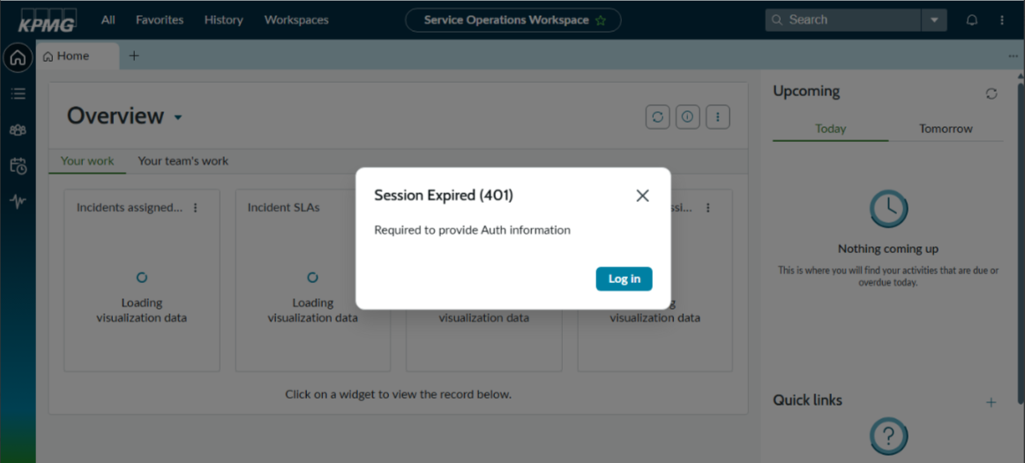
Figure 1

- Click the “X” button on the popup dialog.
- Observe that the application reloads the same page rather than redirecting the user to the login page.
Remediation:
Consider automatically redirecting users to the login page once the session expires rather than allowing the interface to remain on the current page after the session expiration popup is closed. This may improve user experience and ensure clearer session state handling.
Closing/Downgrading Justification:

Appendix

Risk Rating Criteria
Overall Risk Rating Matrix
Likelihood | Impact
 | Negligible | Minor | Moderate | Significant | Severe
Very High | Low | Medium | High | High | Very High
High | Low | Medium | Medium | High | High
Medium | Low | Low | Medium | Medium | High
Low | Low | Low | Low | Medium | Medium
Very Low | Informational | Low | Low | Low | Low

Likelihood * Impact Risk Rating  Risk Rating Value  Very High 25  High 15-20  Medium 7-14  Low 1-6  Informational 1 | Risk Rating is determined by multiplying Impact * Likelihood  Examples:  Likelihood Low (2) * Impact Moderate (3) = 6 (Low)  Likelihood High (4) * Impact Moderate (3) = 12 (Medium)  Likelihood Very High (5) * Impact Severe (5) = 25 (Very High)

Impact Rating Guidance
Severe | Typically reserved for compromise (e.g. data exfiltration, ransomware) of DC3-type datasets, passwords/credentials with access to significant resources, or complete takeover of a system which has significant impacts to KPMG for lateral-based movement/attacks and disruption to the business (e.g. RP0/RP1-rated systems such as Active Directory).
Significant | Typically reserved for compromise (e.g. data exfiltration, ransomware) of DC3-type datasets, passwords/credentials with access to significant resources, or complete takeover of a system which has significant impacts to KPMG for lateral-based movement/attacks and disruption to the business.
Moderate | Typically reserved for compromise (e.g. data exfiltration, ransomware) of DC2-type datasets or partial takeover of a system which has moderate impacts to the business (e.g. RP2-rated systems such as a Business Application).
Minor | Typically reserved for compromise (e.g. data exfiltration, ransomware) of low-risk datasets such as DC1 or partial takeover of a system which has low impact of disruption to the business (e.g. RP3/4-rated systems).
Negligible | Reserved to document findings which have no material impact to KPMG or the Business.

Terminology
Depending on likelihood and impact, the findings will be assigned to one of the following risk ratings:
Very High
Very high risk findings represent a severe weakness that can be easily exploited by an adversary, leading to a direct and immediate impact on the business. This could include a full system compromise, significant data exfiltration, or a widespread denial-of-service condition. Such vulnerabilities pose the highest level of security risk.
Immediate action is required. For systems not yet in production, remediation must be completed before the "go-live" date. For production systems, remediation must be completed within five (5) days of the preliminary report date.

High
A high risk finding indicates a significant weakness that, if exploited, could result in substantial damage to business assets or reputation. Exploitation may require more specific conditions or attacker skill than a critical finding but still presents a high degree of security risk.
For systems not yet in production, remediation must be completed before the "go-live" date. For production systems, remediation must be completed within thirty (30) days of the preliminary report date.

Medium
A medium risk finding points to a moderate security weakness. While it may not lead to a full system compromise on its own, it could be leveraged by an attacker in conjunction with other vulnerabilities to achieve a greater impact or could result in minor data leakage or service degradation.
For systems not yet in production, remediation should be completed before the "go-live" date. For production systems, remediation must be completed within sixty (60) days of the preliminary report date.

Low
A low risk finding identifies a minor security weakness that has a limited potential for impact. Exploiting such a flaw is often difficult or would result in minimal damage. These findings typically represent a minor security risk but should be addressed to maintain a strong security posture.
Remediation for low-risk findings is recommended to be included in the next scheduled product update or maintenance cycle.

Informational
An informational finding is an observation that does not represent an immediately exploitable vulnerability but highlights a deviation from security best practices, a configuration weakness, or unusual system behavior that could pose a risk in the future.
No formal Remediation SLA is defined for informational findings. These are provided for consideration to improve overall security hygiene.

Methodology
Our security assessment follows a structured methodology designed to provide comprehensive and rigorous testing, from initial discovery to final reporting.

Reconnaissance and Discovery
The engagement begins with defining the external attack surface. We conduct reconnaissance to map the client's internet-facing infrastructure, using a combination of public sources and specialized tools. The objective is to identify all associated IP blocks, hostnames, domains, and subdomains. This process reveals the full scope of potential targets and informs the subsequent stages of the assessment.

Threat Modeling and Analysis
Following discovery, each in-scope application is analyzed to create a comprehensive threat model. We map critical information flows, business logic, user roles, architectural dependencies (e.g., web servers, APIs, databases), and third-party components. This analysis allows us to identify likely threat actors, define key attack vectors, and prioritize testing efforts based on the application's unique risk profile.

Application Enumeration and Profiling
With the attack surface defined, we actively enumerate the target applications to build a detailed service and functionality profile. Using a variety of tools and manual techniques, we gather in-depth information about the application's structure, technologies, and exposed resources. This intelligence gathering is crucial for identifying specific modules, functions, and configurations that will be targeted during vulnerability testing.

Vulnerability and Security Control Analysis
This is the core testing stage where we execute a comprehensive vulnerability assessment to identify security weaknesses. Our methodology is guided by industry-standard frameworks, including the OWASP Top 10, CWE Top 25, and MITRE ATT&CK®. We employ a combination of automated scanning and rigorous manual testing to evaluate the effectiveness of existing security controls across several key categories:
- Information Gathering
- Configuration and Deployment Management
- Authentication and Authorization
- Session Management
- Input Validation and Sanitization
- Cryptography and Data Protection
This hybrid approach ensures we identify both known vulnerabilities and complex, logic-based flaws that automated tools often miss.

Exploitation and Impact Validation
This activity validates the real-world impact of vulnerabilities identified during the assessment. We perform controlled exploitation of discovered weaknesses to determine the severity and potential business impact. By simulating adversarial tactics, we demonstrate how an attacker could compromise the application, escalate privileges, or access sensitive data, providing clear evidence of the risk.

Mitigation and Remediation Strategy
Based on the findings from the engagement, we develop a comprehensive mitigation plan. This includes providing tactical recommendations for addressing each specific vulnerability, as well as strategic guidance on secure development practices to enhance the overall security posture of the application.

Reporting
The final activity involves documenting all observations, findings, and recommendations in a formal report. Each vulnerability is assigned a risk rating based on the Common Vulnerability Scoring System (CVSS v3.1) and mapped to relevant CWE identifiers. The report delivers a clear, actionable summary for stakeholders and detailed technical analysis for engineering teams.

DSG Disclaimer Notice
Cybersecurity threats are continually changing, with new vulnerabilities discovered on a daily basis, and no application can ever be 100% secure no matter how much security testing is conducted. This report cannot and does not protect against personal or business loss as the result of use of the applications or systems described. DSG offers no warranties, representations or legal certifications concerning the applications or systems it tests.

All software includes defects: nothing in this document is intended to represent or warrant that security testing was complete and without error, nor does this document represent or warrant that the application tested is suitable to task, free of other defects than reported, fully compliant with any industry standards, or fully compatible with any operating system, hardware, or other application. By using this reported information, you agree that DSG shall be held harmless in any event.

Non-Production and Production Testing Advisory
It is important for the customer to understand that the engagement testing in non-production environments such as UAT (User Acceptance Testing) or QC (Quality Control) represents what is found only in such environments. If there are inaccuracies, omissions, or changes made during or after the testing engagement; this may impact findings visibility and ultimately the accuracy of this report. It is equally important to note that UAT and QC environments should ultimately mimic the production environment. DSG pen testers, unless at the request of the customer, do not typically perform testing within a production environment for general stability and safety concerns. If production testing is a requirement by the SRM (Security Relationship Manager), please create a separate PTI (Penetration Testing Intake) form for as such and notify the DSG pen testers.

Modifications during Testing Engagements
If the customer performs any modifications or changes to the testing environment during an engagement, this may adversely impact the accuracy of the report and findings. Customers should be prepared to freeze changes where possible. If it is not possible, please notify the DSG pen testers of the intended change, time of change, and to which assets it will affect.

Scope of Findings Disclaimer
This report provides representative examples of vulnerabilities identified during the assessment. These examples should not be considered exhaustive. We recommend implementing a comprehensive, systemic remediation approach to address all potential instances of the identified issues, rather than limiting corrective actions to only the specific examples outlined in this report.

Contact us

Digital Security Group
Adversarial Testing
US-DLBPGAdversarialTestingAll@kpmg.com

